Ankit/Anurag,

As discussed in today’s call we have implemented the Parent determintation logic in Intraday as per the approved flow from Patrick displayed below.

You will need to implement the similar lookup when populating the flattened CounterParty table for EOD. We can discuss further in tomorrow’s call.

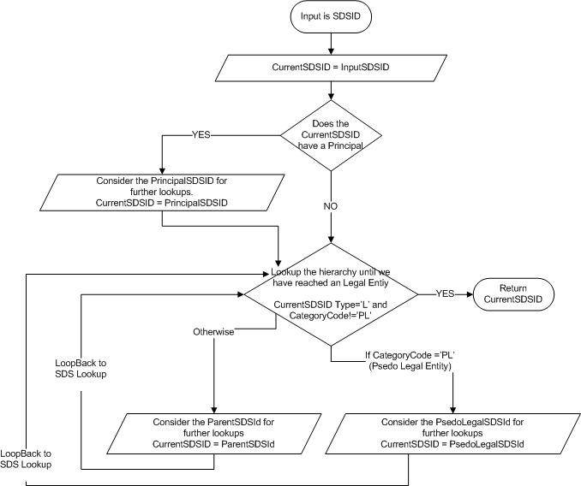

Thanks,

Sameer Ahmed Merchant

212-320-3476